Deployment of App in IBM Cloud

**Containerize the App**

|  |  |
| --- | --- |
| Team ID | PNT2022TMID43211 |
| Project Name | Nutrition Assistant Application |

**Step – 1 :** Create a docker file and paste the code

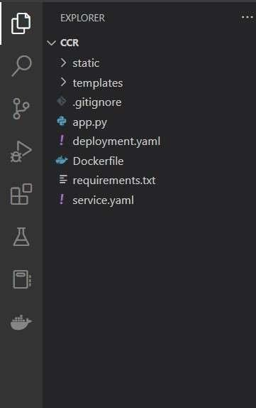

**Step - 2** : Build an image from the docker file.

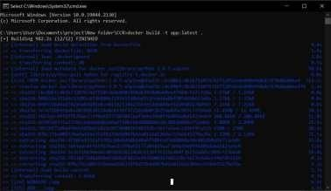

**Step - 3** : Run your container locally.

